Identity Matrix Robert Dilts' Model

 | What I am not | What I could become | What I am
What I want to be
  LIMITS (frustration)
  Personal: What you want to be but feel you are not.
  E.g.: «I wish I were more daring, but I feel timid»
  • I want to be someone who helps others without compromising my values.
  • I don't want to feel like I have to do questionable things to fit in.
  • I want to be respected for my integrity and ethical standards.
  Professional: What you want to embody at work but feels out of reach.
  E.g.: «I wish I were an inspiring leader, but I lack confidence»
  • I want to be a leader who mentors others to stay ethical in their work.
  • I don't want to be just a number entry person without understanding the bigger picture.
  • I want to be in a position where I can influence the firm's ethical direction.
  POTENTIAL (hope, excitement)
  Personal: What you could become, possibilities that inspire you.
  E.g.: «I could become someone more serene and grounded»
  • I want to continue helping people with their taxes and making sure they don't get in trouble.
  • I love solving problems and working with numbers, and I want to keep doing that.
  • I want to be someone others can come to for advice and guidance in the accounting field.
  Professional: Professional growth opportunities you foresee.
  E.g.: «I could become a recognized facilitator»
  • I want to become a CPA and move into a management or director role in a public accounting firm.
  • I want to lead by example and be in a position where I can mentor younger accountants.
  • I want to work in a firm that values ethics and integrity in accounting practices.
  DEEP NATURE (peace, satisfaction)
  Personal: What you have always been, your fundamental essence.
  E.g.: «I have always been a curious and caring person»
  • I want to be someone who helps others understand taxes without confusion.
  • I want to continue being passionate about numbers and solving problems.
  • I want to be someone who serves others with integrity and honesty.
  Professional: Your fundamental professional identity.
  E.g.: «I am fundamentally a change agent»
  • I want to be a CPA and a leader in my field.
  • I want to be in a position where I can guide and mentor others.
  • I want to be part of a firm that values ethics and legal compliance.
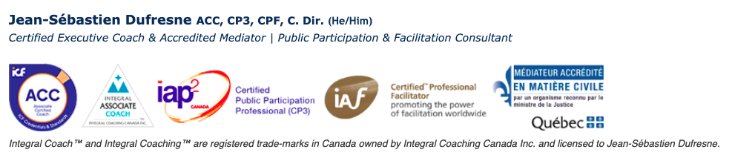
Identity Matrix (continued)

 | What I am not | What I could become | What I am
What I don't want to be
  BOUNDARIES (determination)
  Personal: What you refuse to be and are convinced you will never be.
  E.g.: «I will never be a dishonest person»
  • I refuse to be someone who is not true to my values.
  • I don't want to compromise my ethics for the sake of fitting in.
  • I am not someone who will ignore the right way just to meet expectations.
  Professional: What you categorically refuse to embody at work.
  E.g.: «I will never be an authoritarian manager»
  • I refuse to be a bookkeeper who does not understand the bigger picture.
  • I don't want to be just a data entry person without any real impact.
  • I am not someone who will blur the lines of tax law for the sake of keeping clients.
  WEAKNESSES (anxiety, fear)
  Personal: What you fear becoming in life.
  E.g.: «I am afraid of becoming a cynical person»
  Professional: Negative professional evolution you dread.
  E.g.: «I fear becoming rigid in my methods»
  SHADOW (shame, guilt)
  Personal: What you do not want to be but recognize as part of you.
  E.g.: «I know I can be impatient even though I wish I weren't»
  Professional: Undesirable professional aspects you carry despite yourself.
  E.g.: «I tend to be overly perfectionist at the expense of the team»

